

Cellinfo
User Guide

Supervisor. | Miss Esha Shahid
Batch. | 2506F2
Group. | B
Serial No. | Enrollment Number | Student Name
1. | Student1669168 | Arbash Murtaza
2. | Student1672376 | Aafia Naz
3. | Student1669153 | Abeera Malik

- Introduction
- Screenshots

- Home (index (1).html)

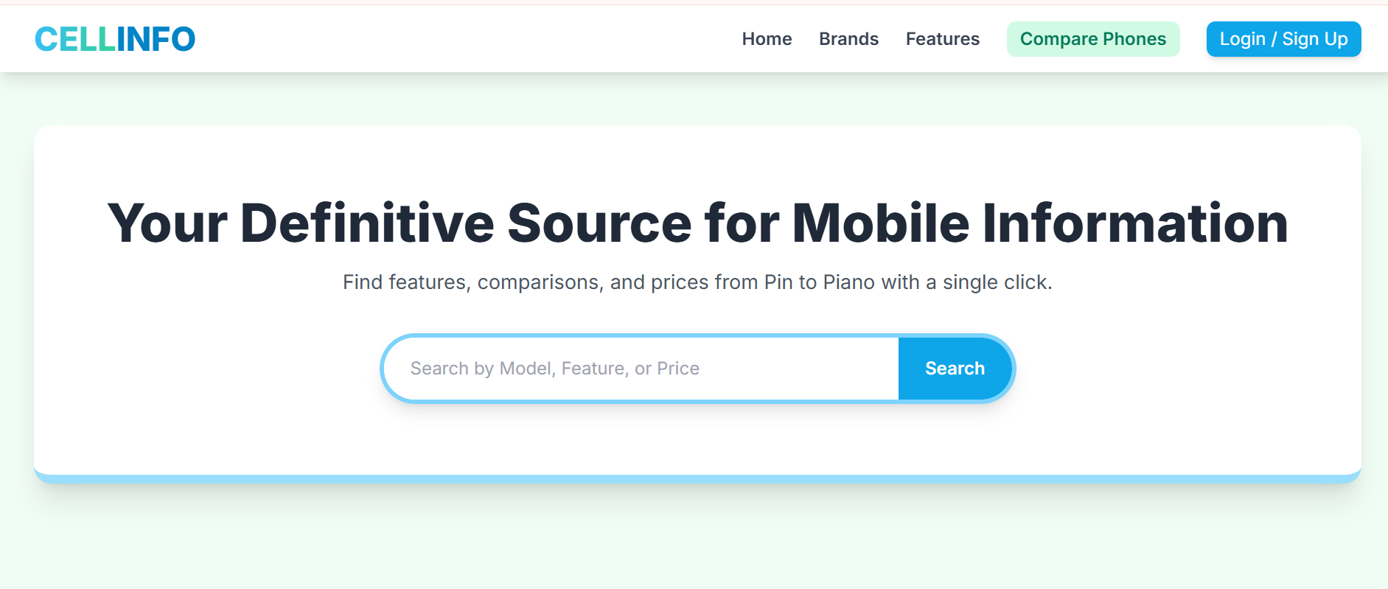

Figure 1: Home page to Cellinfo

- By clicking (home) button user while redirect to the main webpage.

Navbar (index (1).html)

Figure 2: Navbar

The navigation bar (navbar) is placed at the top of the website and provides quick access to the main sections of the site. We have given 5 essentials. By clicking any of the essential’s and redirect to the linked page. (0. Index (1).html)

It typically includes links such as Home, All Brands, Compare Now, Feature, Login, and Signup. The navbar allows users to move between different pages easily and improves the overall user experience by maintaining consistent navigation across all pages.

- Brands (index (1).html)

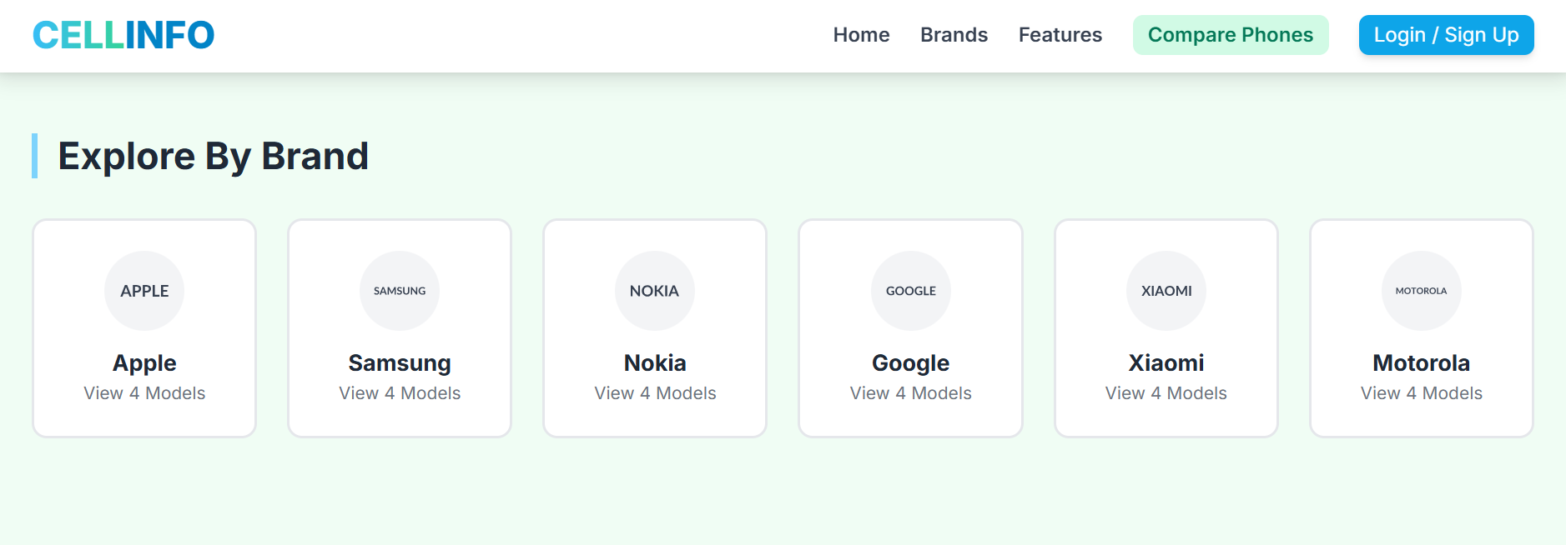

Figure 3: Brands
 Explore different Mobile phone brands there new features and models.
 Discover all about our Cell phones information experience.

4.Features (index (1).html)

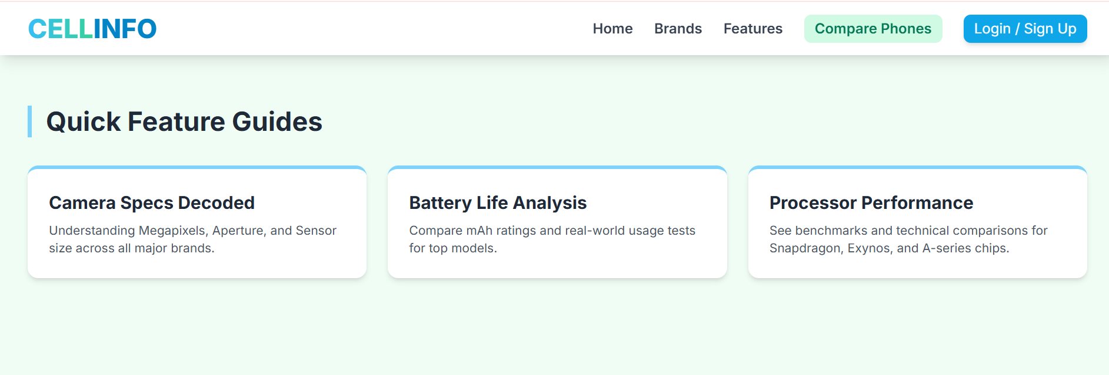
Figure 4: Features

We have mentioned our Mobile phone features to make people known about the phones information we provide.

5.Compare Phones (index (1).html)

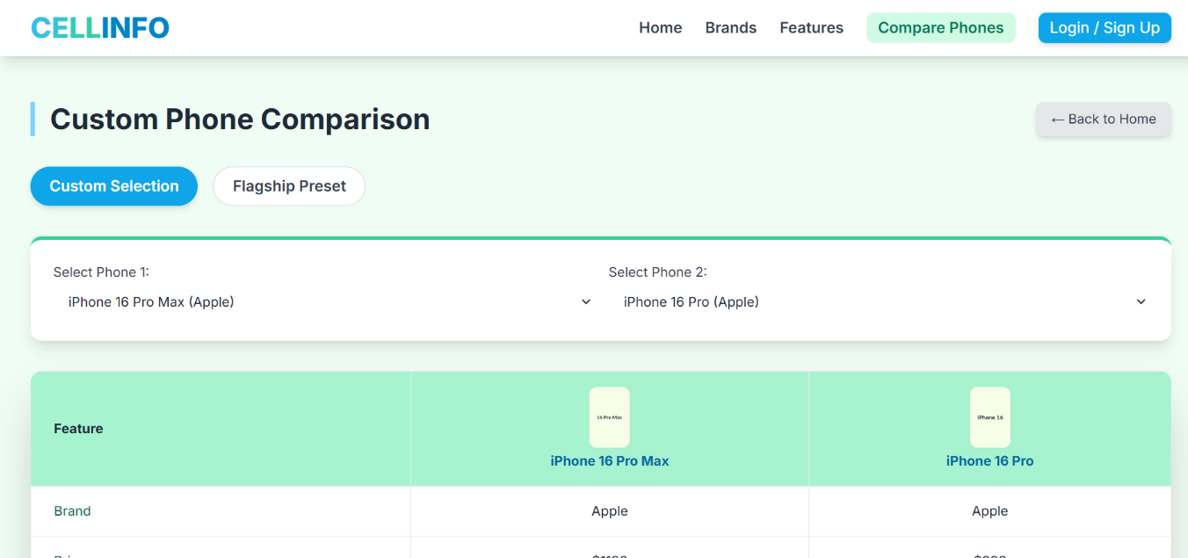

Figure 5: Comparison Of Phones
Description: The Compare page allows users to easily compare the latest mobile phones side by side. You can select any two or more specifications, features, and prices to help you choose the best option for your needs.

6.Menu bar:

Figure 6: Description of our Menu bar

Use to load the remaining sections. The following is a list of those sections:
As we have work on only single page and re-directing on other sections. So, we are made our web directed pages.
- Home Page (1. index (1).html)
- Brands Page (2. index (1).html- Brand Section)
- Features Page (3. index (1).html-Features Section)
- Compare Phones Page (4. index (1).html-Comparison Section)

7.Our Team (index (1).html):
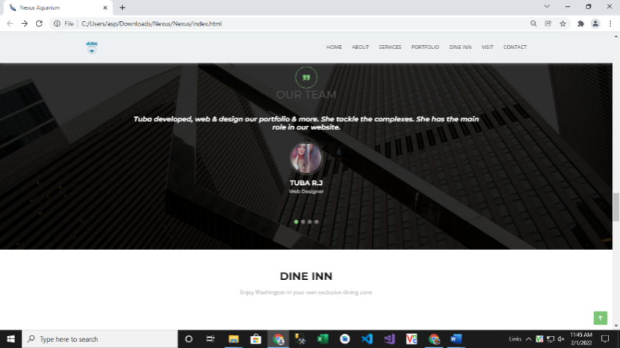

Web Designer
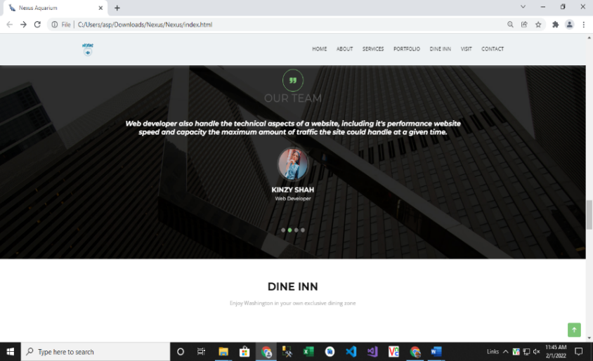

Web Developer
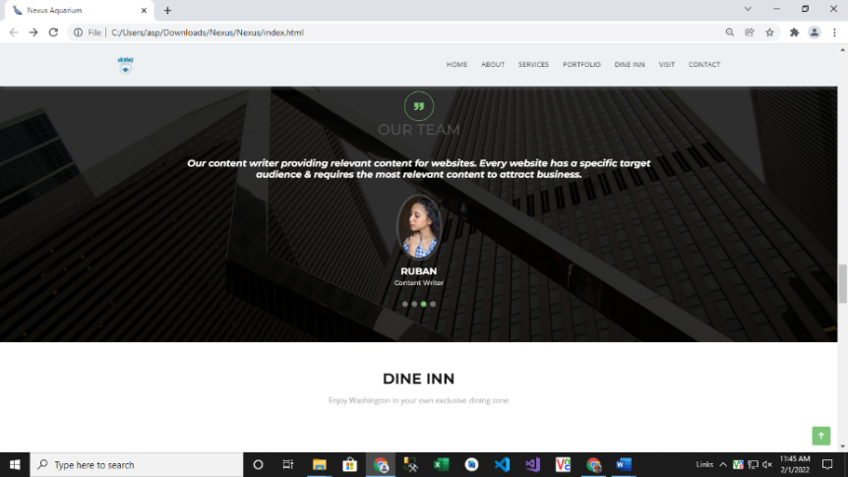

Content Writer
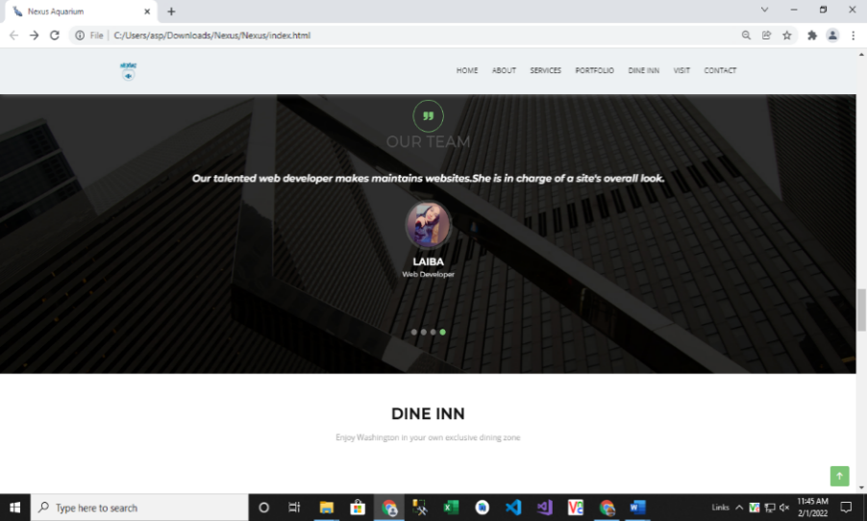

Web Developer

8.Login (index (1).html):

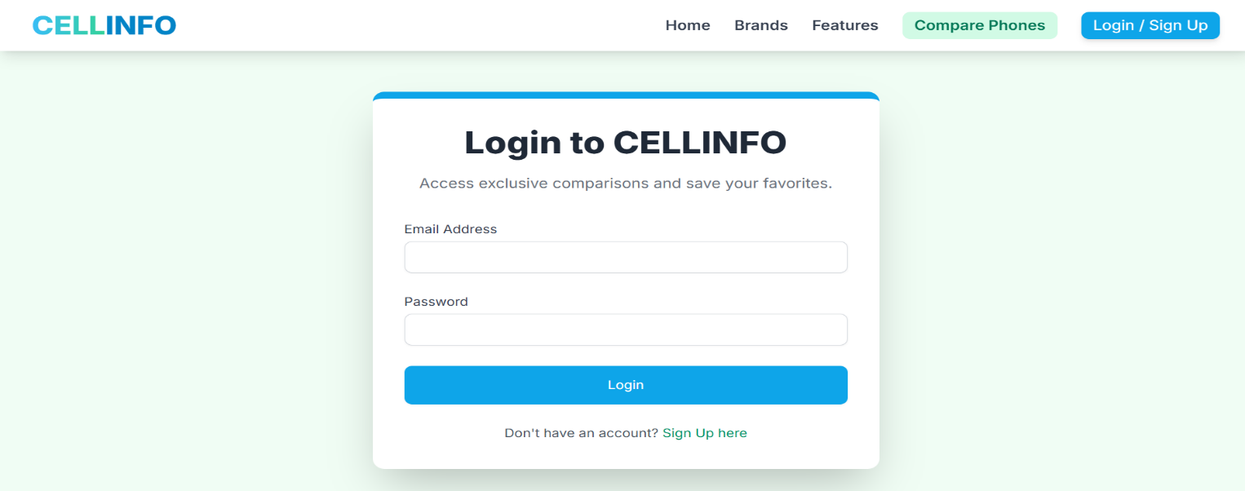
Figure 8: Login

The Login page allows registered users to securely access their accounts. Users can enter their email and password to log in and access personalized features of the website.

9. Signup (index (1).html):

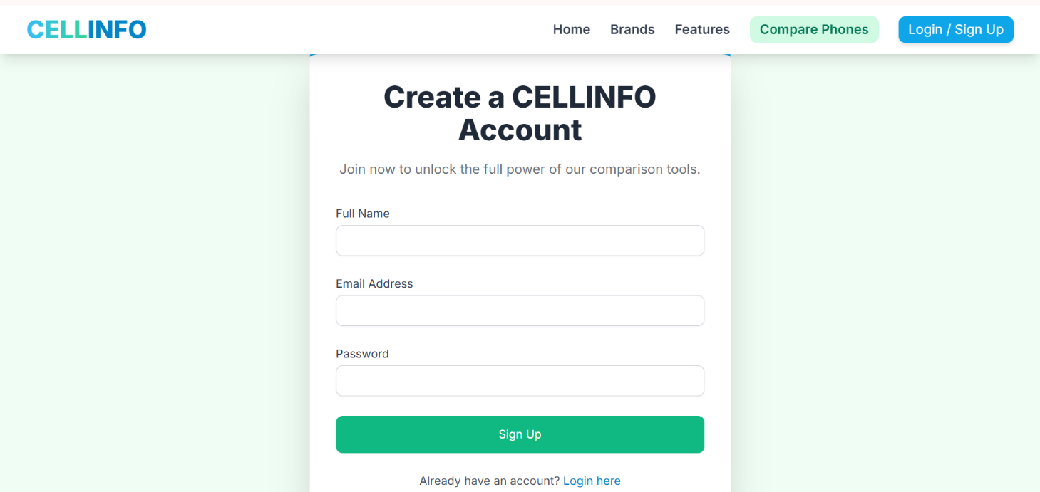

Figure 9: Signup

The Signup page allows new users to create an account on the website. Users can enter their basic information, such as name, email, and password, to register and gain access to all features of the platform.

10.Contact (index (1).html):


Figure 10: Contact

This section ensures that users have a direct way to communicate with the CellInfo team regarding any questions or issues.

11:Footer(index (1).html):



Figure 11: Footer
The footer section of the website provides quick access to essential information and links. It is divided into four main parts:
- Brand Info: Displays the website name CELLINFO along with a short tagline describing its purpose.
- Contact Us: Shows the official address, phone number, and email for communication.
- Quick Access: Includes direct links to important pages like All Brands, Compare Now, and Account.
- Connect: Provides social media icons (GitHub, Facebook, Instagram, and Twitter) to connect with the platform on various networks.
The footer ensures easy navigation, enhances brand visibility, and offers multiple ways for users to stay connected with the website.

